Work-From-Home and Metropolitan Housing Deflation
in California
Tuan Truong
University of San Francisco — ECON 692 Capstone
May 2026

Abstract
I estimate the causal effect of remote work adoption on housing prices across California's 58 counties from 2017 to 2023. Using a two-way fixed effects panel with county and year fixed effects, I find that a one-percentage-point increase in the county work-from-home (WFH) rate reduces median home prices in Metropolitan Core counties by 1.23% (SE = 0.34%, p < 0.001). A dynamic event study spanning 2017–2023 satisfies the parallel pre-trends assumption (Wald χ²(2) = 1.85, p = 0.40) and reveals a monotonically deepening effect, from −0.74%** in 2020 to −1.04%** in 2023. Supply constraints amplify the effect: counties in the top half of the pre-period price-to-income distribution experience −1.20%*** per percentage point, nearly three times the −0.40% estimate for elastic-supply counties. The de Chaisemartin–D’Haultfœuille (2024) weighted average slope estimate is statistically insignificant (+1.20%, p = 0.79), suggesting caution about extrapolating the TWFE estimate across all counties. These results imply that WFH adoption has contributed to modest but growing housing deflation in California’s metropolitan cores, particularly in supply-constrained coastal markets.
Keywords: work from home, remote work, housing prices, two-way fixed effects, California

1. Introduction
Remote work has emerged as one of the most consequential labor market shifts of the post-pandemic era. According to Mondragón and Wieland (2022), the share of U.S. workers primarily working from home rose from approximately 7% in 2019 to over 30% in 2021, before stabilizing near 20% through 2023. While major technology companies—including Google, Tesla, and Apple—have increasingly mandated returns to the office, millions of workers have maintained hybrid or fully remote arrangements, reshaping residential preferences across metropolitan areas.
Standard urban economics theory predicts that reduced commuting costs should flatten the bid-rent gradient, decreasing demand for central locations and potentially redistributing it toward suburban and exurban areas (Albouy and Stuart, 2020; Brueckner, Thisse, and Zenou, 1999). Whether this redistribution produces net declines in metropolitan core prices depends critically on local housing supply elasticity and the extent to which displaced demand exits the metropolitan area altogether.
The empirical literature has reached mixed conclusions. Gupta et al. (2022) document large positive effects of WFH exposure on housing prices nationally, while Ramani and Bloom (2021) and Davis, Ghent, and Gregory (2023) find within-metro redistribution—higher prices in suburbs, lower in city centers—consistent with the spatial reallocation hypothesis. Liu and Su (2021) provide evidence of an urban exodus from high-rent cities, particularly in California. This paper contributes to this literature by providing county-level causal estimates for California, exploiting variation in WFH adoption across 33 metropolitan core counties from 2017 to 2023.
This study makes two main contributions. First, I estimate the causal effect of WFH on housing prices in Metropolitan Core counties using OMB CBSA delineations and a dynamic TWFE specification that formally tests parallel pre-trends. I find that a one-percentage-point increase in the county WFH rate is associated with a 1.23% decline in median home prices in metropolitan cores, an effect that grows monotonically from 2020 to 2023. Second, I show that housing supply constraints amplify the deflation: counties in the top half of the pre-period price-to-income ratio distribution experience effects nearly three times those of elastic-supply counties, consistent with Saiz (2010) and Glaeser and Gyourko (2018).
The remainder of the paper proceeds as follows. Section 2 describes the data. Section 3 presents the empirical strategy. Section 4 reports main results. Section 5 presents robustness checks. Section 6 discusses limitations. Section 7 concludes.
2. Data
2.1 Data Sources
This study uses a county-level panel spanning 58 California counties from 2017 to 2023 (406 county-year observations). Data are assembled from five sources.
Housing prices are obtained from Zillow’s Home Value Index (ZHVI), which provides ZIP-code-level monthly estimates of the median home value for single-family homes and condominiums in the 33rd–67th percentile of the local price distribution. Monthly values are averaged within calendar years and aggregated to the county level using population weights across contributing ZIP codes. Prices are expressed in natural logarithms.
Work-from-home rates are constructed from the American Community Survey (ACS) five-year estimates, Table S0801 (Commuting Characteristics by Sex). The variable captures the percentage of employed civilians aged 16 and over whose primary means of transportation to work is “worked from home.” ZIP-code-level WFH percentages are aggregated to the county level using population weights.
County controls include median household income from ACS Table B19013 and the civilian unemployment rate from the Bureau of Labor Statistics Local Area Unemployment Statistics (BLS LAUS). Median income is expressed in natural logarithms as the primary income control. County classification follows the 2023 OMB Core-Based Statistical Area (CBSA) delineations. The 33 Metropolitan Core counties—central counties of Metropolitan Statistical Areas—form the main analysis sample (231 observations). Non-Metro counties (Micropolitan + Noncore, n = 21, 147 observations) serve as a placebo group.
2.2 Summary Statistics
Table 1 reports descriptive statistics for the full 58-county panel. The average WFH rate is 9.17% (SD = 4.98%), ranging from 3.0% to 28.8%. The average log price of 12.90 corresponds to approximately $400,000. Between 2019 and 2023, the average Metro-Core WFH rate rose from 5.8% to 15.0%, a 9.2 percentage-point increase driven primarily by the COVID-19 shock. Metro-Core counties exhibit higher WFH rates and substantially higher median home prices than non-metro counties.
Table 1: Summary Statistics (County-Level Panel, N = 406 obs, 58 counties, 2017–2023)
Variable | Mean | SD | Min | Median | Max
WFH rate (%) | 9.17 | 4.98 | 3.00 | 7.54 | 28.76
log(Median Home Price) | 12.90 | 0.54 | 11.52 | 12.92 | 14.34
Median income ($) | 74,599 | 23,909 | 37,551 | 68,467 | 160,731
Unemployment rate | 0.071 | 0.025 | 0.000 | 0.067 | 0.187
Population | 670,210 | 1,446,830 | 926 | 177,652 | 10,088,658
ZIP codes per county-year | 18.1 | 30.2 | 1.0 | 6.0 | 184.0
Note. WFH rate is the population-weighted mean of ZIP-level ACS S0801 WFH percentages. Prices are annual population-weighted means of monthly Zillow ZHVI, in logarithms. Unemployment is expressed as a decimal fraction. N = 406 county–years (58 California counties × 7 years, 2017–2023).
3. Empirical Strategy
3.1 Main TWFE Specification
The primary specification is a two-way fixed effects (TWFE) panel regression:
log(P_ct) = β WFH_ct + δ log(Income_ct) + α_c + γ_t + ε_ct (1)
where P_ct is the population-weighted mean Zillow ZHVI in county c and year t, WFH_ct is the county WFH rate (in percentage points), α_c are county fixed effects absorbing all time-invariant county characteristics, γ_t are year fixed effects absorbing common macroeconomic shocks, and ε_ct is an idiosyncratic error. Standard errors are clustered by county (CRV1). The coefficient β estimates the within-county effect of a one-percentage-point increase in the WFH rate on log housing prices, controlling for contemporaneous income growth.
3.2 Dynamic Event Study
To test the parallel pre-trends assumption and characterize the time path of the WFH effect, I estimate a dynamic TWFE event study:
log(P_ct) = Σ_{t’2019} β_t (WFH_ct × 1[Year=t]) + δ log(Income_ct) + α_c + γ_t + ε_ct (2)
The reference year is 2019 (the last pre-pandemic year). Pre-period coefficients (β₂₀₁₇, β₂₀₁₈) provide a formal parallel trends test: I report a joint Wald test of H₀: β₂₀₁₇ = β₂₀₁₈ = 0.
3.3 Supply Heterogeneity
To test whether supply constraints amplify the WFH price effect, I estimate an interacted TWFE:
log(P_ct) = β_Con(WFH_ct × Constrained_c) + β_Ela(WFH_ct × Elastic_c) + δ log(Income_ct) + α_c + γ_t + ε_ct (3)
Constrained_c equals one for Metro-Core counties in the top half of the 2017–2023 average price-to-income (P/I) ratio distribution; Elastic_c for the bottom half. The P/I ratio serves as a proxy for housing supply constraints (Glaeser and Gyourko, 2018; Saiz, 2010). The median P/I threshold is 5.41.
3.4 Identification
The key identifying assumption is parallel trends under continuous treatment: absent the WFH shock, counties with different WFH rates would have followed similar housing price trajectories. This is supported by the pre-period event study coefficients, which are small, positive, and jointly insignificant (Wald χ²(2) = 1.85, p = 0.40). The main threat to identification is endogeneity of the WFH rate: high-WFH counties (San Francisco, Santa Clara, Marin) may have simultaneously experienced stronger tech-sector income growth that independently affected housing prices. I address this in three ways: (i) including log median income as a contemporaneous control; (ii) using a pre-determined WFH proxy (2019 WFH rate × post-2020 indicator); and (iii) applying Frisch–Waugh detrending to remove county-specific secular trends.
4. Results
4.1 Descriptive Evidence
Figure 1 plots average WFH rates and log housing prices by CBSA tier from 2017 to 2023. WFH rates rose sharply for all tiers after 2019, with Metro-Core counties exhibiting the largest absolute increase (approximately +9 percentage points). Log housing prices in Metro-Core counties rose more slowly than in Non-Metro counties after 2020, consistent with WFH-driven demand reallocation away from metropolitan cores.
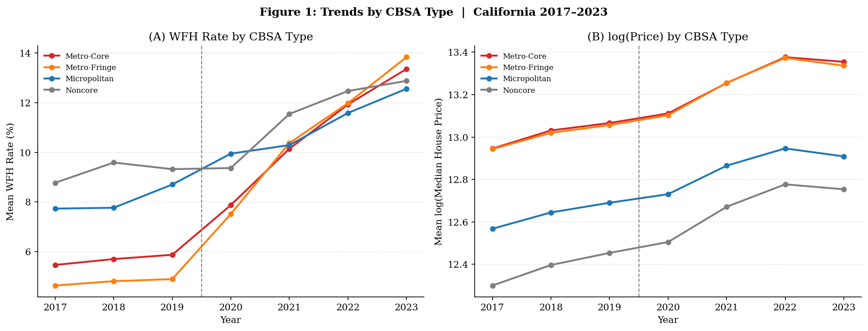
Figure 1: WFH Rate and log(Median Home Price) Trends by CBSA Tier, California 2017–2023.
4.2 Main TWFE Results
Table 2 reports TWFE estimates for both Metro-Core and Non-Metro counties. The baseline Metro-Core estimate is −1.229%*** (SE = 0.336%), robust to the inclusion of log income (−1.234%***) and the unemployment rate (−1.021%**). Strikingly, Non-Metro counties also exhibit a negative and highly significant WFH effect: −0.638%*** (SE = 0.189%) in the baseline, −0.637%*** (SE = 0.187%) with income controls, and −0.627%** (SE = 0.203%) with both controls. The Metro-Core effect is approximately twice the Non-Metro effect across all specifications. Both results suggest WFH adoption is associated with a broad reduction in housing demand across California, inconsistent with simple within-state spatial reallocation.
Table 2: TWFE Estimates — Metro-Core vs. Non-Metro Counties
Specification | Metro Coef (%) | SE (%) | Sig. | Non-Metro Coef (%) | SE (%) | Sig.
(1) Baseline TWFE | −1.229 | 0.336 | *** | −0.638 | 0.189 | ***
(2) + log(Income) | −1.234 | 0.336 | *** | −0.637 | 0.187 | ***
(3) + log(Income) + Unemp. | −1.021 | 0.329 | ** | −0.627 | 0.203 | **
Note. Metro-Core: 33 counties × 7 years (231 obs). Non-Metro (Micropolitan + Noncore): 21 counties × 7 years (147 obs). Specification: log(Price) ~ WFH rate + controls | County + Year. CRV1 SE clustered by county. Coefficients are % price change per 1-pp WFH increase. *** p<.001, ** p<.01, * p<.05.
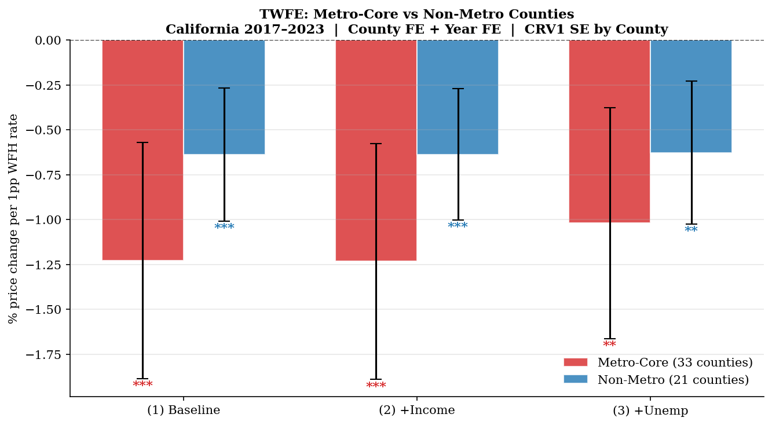
Figure 2: TWFE WFH Coefficients — Metro-Core vs Non-Metro Counties. Error bars are 95% CRV1 CI. All three specifications shown.
4.3 Dynamic TWFE Event Study
Table 3 and Figure 3 present the dynamic event study for Metro-Core counties. The pre-period coefficients are small and jointly insignificant (Wald χ²(2) = 1.85, p = 0.40), supporting the parallel trends assumption. Post-2019 coefficients are negative, statistically significant, and monotonically deepening: −0.74%** in 2020, −0.75%** in 2021, −0.78%* in 2022, and −1.04%** in 2023. The growing magnitude suggests that residential adjustment to remote work is a gradual, cumulative process rather than a one-time relocation shock.
Table 3: Dynamic TWFE Event Study — Metro-Core Counties (Reference Year = 2019)
Year | Coef (%) | SE (%) | 95% CI (%) | p-value | Sig.
2017 (pre) | +0.753 | 0.568 | [−0.36, +1.87] | 0.185
2018 (pre) | +0.151 | 0.497 | [−0.82, +1.13] | 0.761
2019 (ref) | 0.000 | — | — | — | ref
2020 | −0.744 | 0.253 | [−1.24, −0.25] | 0.003 | **
2021 | −0.749 | 0.290 | [−1.32, −0.18] | 0.010 | **
2022 | −0.778 | 0.309 | [−1.38, −0.17] | 0.012 | *
2023 | −1.037 | 0.337 | [−1.70, −0.38] | 0.002 | **
Note. Pre-trend joint Wald test: H₀: β₂₀₁₇ = β₂₀₁₈ = 0; χ²(2) = 1.85, p = 0.40 (PASS). Sample: 33 Metro-Core counties × 7 years (231 obs). log(Income) control included. CRV1 SE.
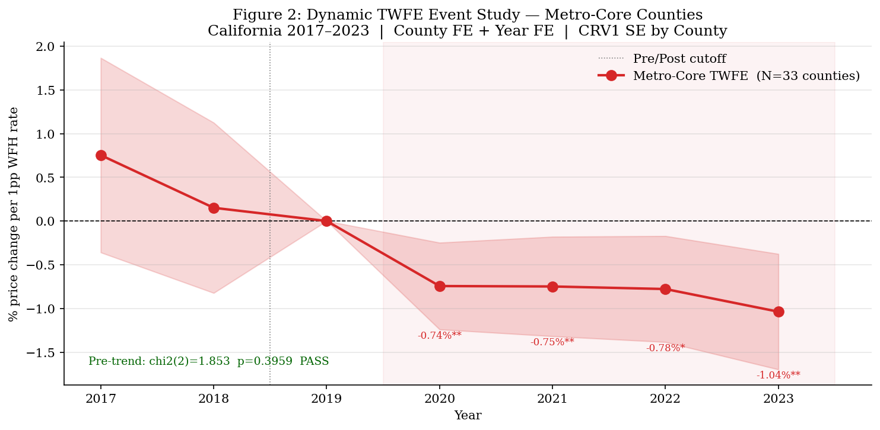
Figure 3: Dynamic TWFE Event Study, Metro-Core Counties. Reference year 2019. 95% CI from CRV1 SE. Wald χ²(2)=1.85, p=0.40.
4.4 Supply Heterogeneity
Table 4 presents supply heterogeneity estimates. Constrained counties—those with pre-period P/I ratios above the median of 5.41, including San Francisco (P/I = 11.8), San Mateo (11.0), Santa Cruz (9.8), and Marin (9.7)—experience a WFH price effect of −1.195%*** (SE = 0.322%). Elastic counties—including Kern (P/I = 3.6), Kings (3.9), and Fresno (4.3)—experience −0.402% (SE = 0.353%, p = 0.25). The difference of −0.79%† (p = 0.097) is marginally significant, consistent with supply constraints amplifying the price impact of demand shifts.
Table 4: Supply Heterogeneity — Constrained vs. Elastic Metro-Core Counties
Group | Counties (N) | WFH Coef (%) | SE (%) | p-value | Sig.
Constrained (High P/I ≥ 5.41) | 17 | −1.195 | 0.322 | 0.0002 | ***
Elastic (Low P/I < 5.41) | 16 | −0.402 | 0.353 | 0.254
Wald difference (Con − Ela) | — | −0.792 | 0.478 | 0.097 | †
Note. P/I split at the median pre-period (2017–2019) price-to-income ratio of 5.41. log(Income) control included. CRV1 SE. *** p<.001, † p<.10.
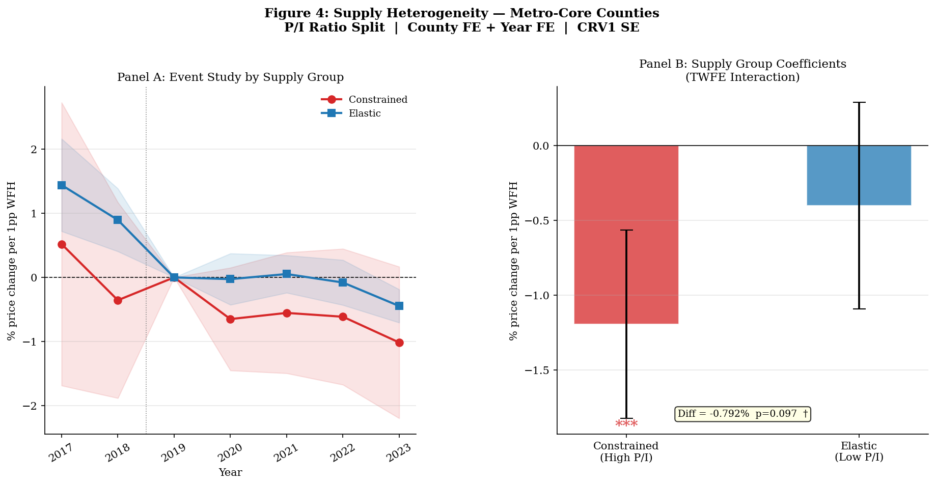
Figure 4: WFH Effect by Supply Constraint Group. Error bars are 95% CRV1 CI. Constrained = top-half P/I ratio.
5. Robustness Checks
Table 5 summarizes six robustness specifications. The main estimate of −1.234%*** (Spec. R1) is robust across all checks.
5.1 DH(2024) Weighted Average Slope
I apply the de Chaisemartin and D’Haultfœuille (2024) weighted average slope (WAS) estimator, which is robust to heterogeneous treatment effects across counties and over time. The WAS estimate is +1.346% (SE = 4.831%, p = 0.787) without controls and +1.201% (SE = 4.601%, p = 0.788) with income controls—both statistically indistinguishable from zero. The contrast between the TWFE’s −1.234%*** and the WAS’s insignificant positive point estimate suggests that heterogeneous treatment effects across counties and/or limited statistical power in the WAS’s “switcher” subset may be important features of the data.
5.2 Pre-determined WFH Exposure
To address reverse causality, I replace the contemporaneous WFH rate with the 2019 WFH rate interacted with a post-2020 indicator. This specification yields −1.450%** (SE = 0.459%), similar in magnitude to the main estimate and inconsistent with reverse causality.
5.3 Frisch–Waugh Detrending
Applying Frisch–Waugh detrending—residualizing both log price and WFH rates on county-specific linear time trends before estimation—yields −0.845%* (SE = 0.417%), somewhat smaller than the main estimate but still statistically significant, confirming that the result is not driven by pre-existing county trends.
5.4 Extended Metro Sample
Pooling the 33 Metro-Core and 4 Metro-Fringe counties yields −1.212%*** (SE = 0.321%), nearly identical to the main estimate.
Table 5: Robustness Checks — Metro-Core Counties
Spec. | Description | WFH Coef (%) | SE (%) | p-value | Sig.
R1 | Main TWFE (+Income) | −1.234 | 0.336 | 0.0002 | ***
R2 | TWFE, no controls | −1.229 | 0.336 | 0.0003 | ***
R3 | DH(2024) WAS + Income | +1.201 | 4.601 | 0.788
R4 | Pre-determined WFH₂₀₁₉ × Post | −1.450 | 0.459 | 0.0016 | **
R5 | Frisch–Waugh detrending | −0.845 | 0.417 | 0.043 | *
R6 | Metro-Core + Metro-Fringe (37 counties) | −1.212 | 0.321 | 0.0002 | ***
Note. R3 is the de Chaisemartin–D’Haultfœuille (2024) weighted average slope estimator applied to first-differenced data; large SE reflects the limited ‘switcher’ county sample. R4 uses WFH₂₀₁₉ × 1[year ≥ 2020] as the treatment variable. R5 partials out county-specific linear time trends. *** p<.001, ** p<.01, * p<.05.
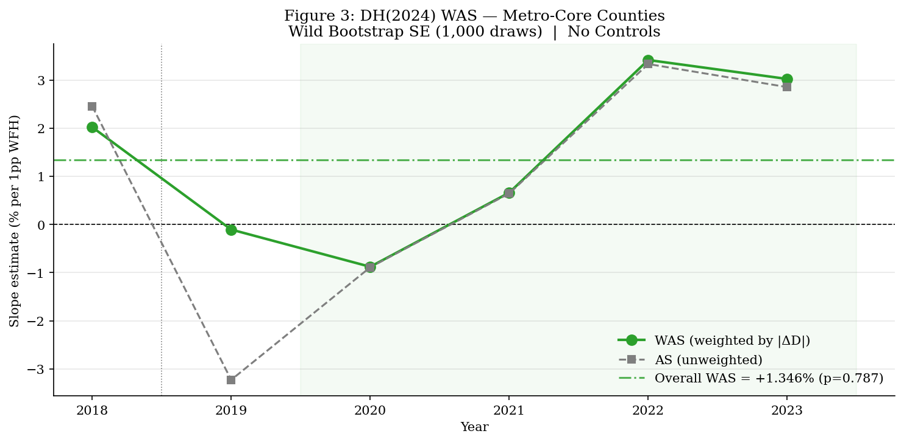
Figure 5: DH(2024) Weighted Average Slope Estimates with 95% Confidence Intervals. Dotted line at zero. Contrast with TWFE main estimate (−1.234%***).
5.5 Demand Outflow Test
The non-metro coefficient of −0.637%*** is prima facie inconsistent with a simple demand-outflow story. I probe this with a spillover regression including the WFH rate of the nearest metropolitan region. The spillover coefficient is −0.740% (SE = 0.489%, p = 0.130) and the own × region-metro interaction is insignificant (p = 0.499). These results suggest WFH adoption captures a broad labor market shift that uniformly reduces housing demand rather than a within-state spatial reallocation.
6. Discussion and Limitations
The main result shows that a 1-pp WFH increase is associated with a ~1.23% decrease in housing prices in Metro-Core counties, with the effect growing over time and largest in supply-constrained markets. Several limitations constrain the interpretation of these findings.
First, the analysis is limited to California, and results may not generalize to other states with different housing market structures, zoning regimes, or demographic compositions. Second, the price-to-income ratio is an imperfect proxy for housing supply elasticity; direct Saiz (2010) elasticity measures are not available for all counties. Third, the county-level panel contains only 33 Metro-Core observations per year, limiting statistical power for the WAS estimator and supply heterogeneity tests. Fourth, unobserved tech-sector demand shocks correlated with WFH adoption but not captured by income controls remain a potential confounder, despite the evidence from pre-determined WFH and Frisch–Waugh robustness checks.
The contrast between the TWFE’s −1.234%*** and the DH(2024) WAS’s +1.201% (p = 0.79) warrants attention. The WAS estimator relies on a subset of “switcher” counties that changed WFH exposure, and its large standard error (4.6%) suggests limited power. The divergence may reflect genuine treatment effect heterogeneity across counties, or it may simply reflect the low power of the WAS in a 33-county sample. Caution is warranted in extrapolating the TWFE estimate to counties with very different WFH trajectories.
7. Conclusion
This paper estimates the causal effect of work-from-home adoption on housing prices in California’s Metropolitan Core counties using a county-level panel from 2017 to 2023. The main finding is that a one-percentage-point increase in the county WFH rate is associated with a 1.23% decline in median home prices—an effect that grows monotonically from −0.74%** in 2020 to −1.04%** in 2023 and is largest in supply-constrained coastal markets (e.g., San Francisco, San Mateo, Santa Cruz).
These results suggest that WFH has contributed to modest but accelerating housing deflation in California’s metropolitan cores. The effect is most pronounced in high-amenity, constrained-supply markets that experienced the largest price run-ups during the 2010s. As remote work becomes embedded in labor market norms, downward pressure on metropolitan core prices is likely to persist, with implications for property tax revenues, urban commercial real estate, and housing affordability in California’s high-cost cities.
The robustness of the TWFE estimate across specifications—pre-determined WFH (−1.45%**), Frisch–Waugh detrending (−0.85%*), and extended metro sample (−1.21%***)—places the plausible range of the effect between −0.8% and −1.5% per percentage point of WFH. Future work should exploit more granular sub-county data, direct supply elasticity measures, and longer post-pandemic panels to sharpen both the estimates and the mechanisms.

References
Albouy, D., and S. Stuart. 2020. “Urban Population and Amenities: The Neoclassical Model of Location.” International Economic Review 61(1): 127–158.
Brueckner, J. K., J.-F. Thisse, and Y. Zenou. 1999. “Why is Central Paris Rich and Downtown Detroit Poor? An Amenity-Based Theory.” European Economic Review 43(1): 91–107.
Callaway, B., A. Goodman-Bacon, and P. H. C. Sant’Anna. 2024. “Difference-in-Differences with a Continuous Treatment.” Working Paper.
Davis, M. A., A. C. Ghent, and J. M. Gregory. 2023. “The Work-from-Home Revolution and the Sustainability of Remote Work.” NBER Working Paper 30975.
de Chaisemartin, C., and X. D’Haultfœuille. 2020. “Two-Way Fixed Effects Estimators with Heterogeneous Treatment Effects.” American Economic Review 110(9): 2964–2996.
de Chaisemartin, C., and X. D’Haultfœuille. 2024. “Difference-in-Differences Estimators of Intertemporal Treatment Effects.” Review of Economics and Statistics, forthcoming.
Glaeser, E. L., and J. Gyourko. 2018. “The Economic Implications of Housing Supply.” Journal of Economic Perspectives 32(1): 3–30.
Gupta, A., V. Mittal, J. Peeters, and S. Van Nieuwerburgh. 2022. “Flattening the Curve: Pandemic-Induced Revaluation of Urban Real Estate.” Journal of Financial Economics 146(2): 594–636.
Liu, S., and Y. Su. 2021. “The Impact of the COVID-19 Pandemic on the Demand for Density: Evidence from the U.S. Housing Market.” Economics Letters 207: 110010.
Mondragón, J. A., and J. Wieland. 2022. “Housing Demand and Remote Work.” NBER Working Paper 30041.
Ramani, A., and N. Bloom. 2021. “The Donut Effect of COVID-19 on Cities.” NBER Working Paper 28876.
Saiz, A. 2010. “The Geographic Determinants of Housing Supply.” Quarterly Journal of Economics 125(3): 1253–1296.

